IT13: ADBMS
Chapter 2:SQL
Practice Assignment Solution Template
ASHUTOSH UTTEKAR 2601196

Write a query and paste a screenshot of your output below the question.
- Create a database named CompanyDB.
create database CompanyDB;
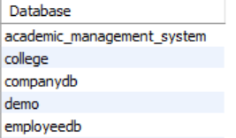

- Create a table Employees with the following columns:
Employees (EmpID (Integer, Primary Key), EmpName, Salary, JoinDate )
Create table Employees (EmpID int primary key , EmpName varchar(10), Salary int , JoinDate date);

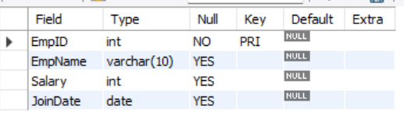

- Create a table Departments with:
Departments (DeptID (Integer, Primary Key), DeptName)
create table Departments (DeptID int primary key , DeptName varchar(20));
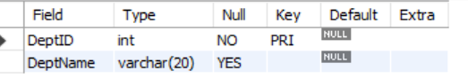

- Add a column Email (VARCHAR(100)) to the Employees table.
alter table employees add column Email VARCHAR(100);
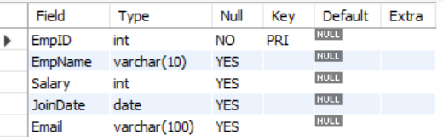

- Add a column dept_location to the Departments table.
alter table departments add column dept_location varchar(50);
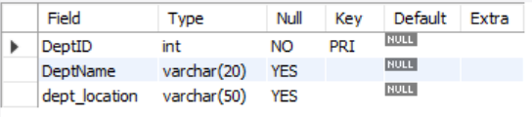

- Add a NOT NULL Constraint to the Phone column
alter table employees add column phone int;
alter table employees modify phone int not null;
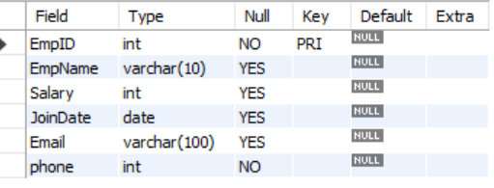

- Change the size of the EmpName column from VARCHAR (50) to VARCHAR (100).
alter table employees modify EmpName varchar(100);
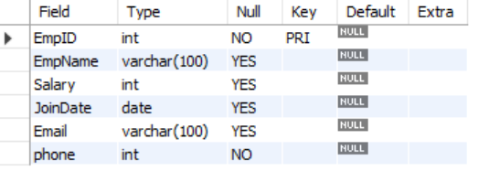

- Drop the primary key Constraint from Departments
alter table departments drop primary key(DeptID);
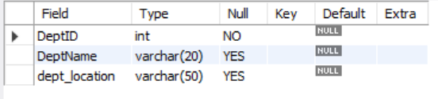

- Create a foreign key constraint between two tables
alter table employees
add constraint fk_dept
foreign key (DeptID)
references departments(DeptID);
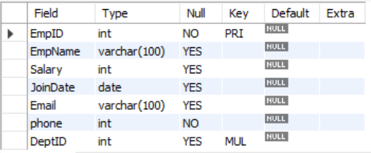

- Rename the column EmpName to EmployeeName.
alter table employees rename column EmpName to EmployeeName;
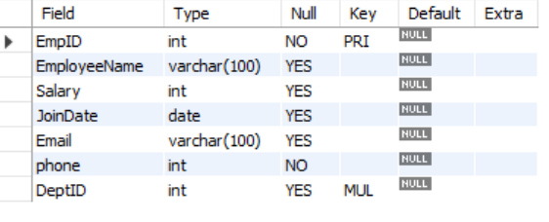

- Apply a CHECK constraint on the Age and Salary columns.
alter table employees add column age int;
alter table Employees
add constraint chk_salary_age
check ((salary>0) and
(age>21));
show create table employees;
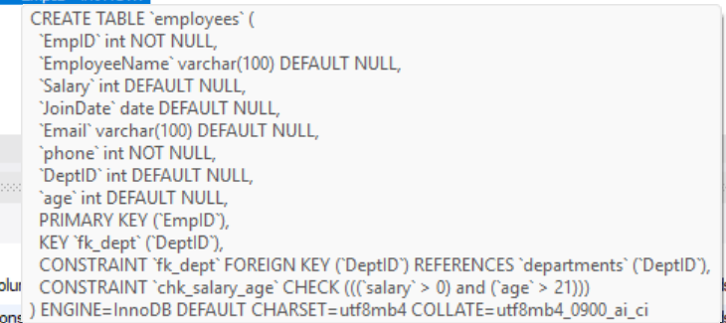

- Remove the Phone column from the Employees table.
alter table employees drop column phone;

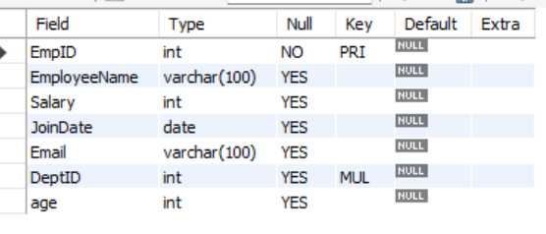

- Rename the table Employees to EmployeeDetails.
rename table employees to EmployeeDetails;
desc EmployeeDetails;
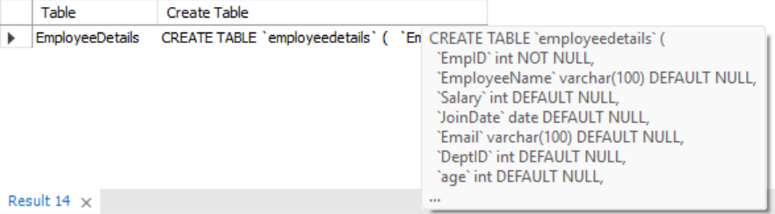

- Drop the CHECK constraints.
alter table EmployeeDetails drop check chk_salary_age;
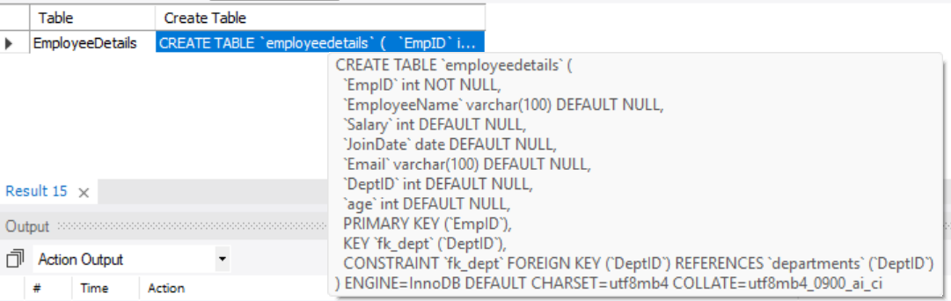

- Delete the Departments table permanently.
drop table departments;
show tables from CompanyDB;

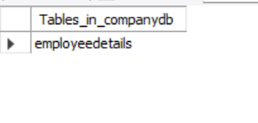

- Drop the database.
drop database CompanyDB;

